Experiment 10: Design of Fully Connected Neural Network using RTL
Objectives
  - To design and simulate a Fully Connected (FC) neural network layer with five input neurons (x0–x4), five weight inputs (w0–w4), and one output neuron (y) using RTL (Verilog HDL).
  - To implement fixed-point signed 8-bit x 8-bit parallel multipliers, a 5-input adder tree accumulator (sum), and a 16-bit signed bias addition stage.
  - To construct a comprehensive Verilog testbench (tb_fully_connected_5in) applying positive, scaled, and signed 2's complement test vectors.
  - To simulate in Vivado Simulator (XSIM), record output waveforms, and verify 100% computational accuracy against manual theoretical MAC calculations.
Required tools
Xilinx Vivado Design Suite, Vivado Simulator (XSIM), Verilog HDL, Windows / Linux Operating System.

Method
- Step 1: Project Creation — Open Xilinx Vivado and create a new RTL project. Select the target FPGA device or board.
- Step 2: Module Architecture & Ports Declaration — Create a Verilog module named fully_connected_5in for the Fully Connected layer. Declare five 8-bit signed input ports (x0 to x4), five 8-bit signed weight ports (w0 to w4), a 16-bit signed bias input (bias), and an 18-bit signed output (y).
- Step 3: MAC Logic Implementation — Implement parallel 8-bit x 8-bit signed multipliers (m0 = x0 * w0 through m4 = x4 * w4), an accumulator tree (sum = m0 + m1 + m2 + m3 + m4), and a bias adder (y = sum + bias).
- Step 4: Testbench Development — Create a Verilog testbench file (tb_fully_connected_5in) instantiating fully_connected_5in. Apply test cases for: (1) All-ones weights with bias 10, (2) Scaled weights x2 with bias 0, and (3) Mixed signed negative inputs with bias 5.
- Step 5: Simulation & Result Verification — Launch Vivado Simulator (XSIM) and execute behavioral simulation. Observe output waveforms for each test case, record y values, and compare them against manual theoretical calculations.

Program

1. Verilog RTL Code: Fully Connected Layer
module fully_connected_5in (
input signed [7:0] x0, x1, x2, x3, x4, // 5 inputs
input signed [7:0] w0, w1, w2, w3, w4, // 5 weights
input signed [15:0] bias, // single bias
output signed [17:0] y // output
);
wire signed [15:0] m0, m1, m2, m3, m4;
wire signed [17:0] sum;
assign m0 = x0 * w0;
assign m1 = x1 * w1;
assign m2 = x2 * w2;
assign m3 = x3 * w3;
assign m4 = x4 * w4;
assign sum = m0 + m1 + m2 + m3 + m4;
assign y = sum + bias;
endmodule

2. Verilog Testbench Code
`timescale 1ns / 1ps
module tb_fully_connected_5in;
reg signed [7:0] x0, x1, x2, x3, x4;
reg signed [7:0] w0, w1, w2, w3, w4;
reg signed [15:0] bias;
wire signed [17:0] y;
// Instantiate the DUT
fully_connected_5in uut (
.x0(x0), .x1(x1), .x2(x2), .x3(x3), .x4(x4),
.w0(w0), .w1(w1), .w2(w2), .w3(w3), .w4(w4),
.bias(bias),
.y(y)
);
initial begin
// Test Case 1: Positive inputs, all-ones weights, bias = 10
x0 = 8'd10; x1 = 8'd20; x2 = 8'd30; x3 = 8'd40; x4 = 8'd50;
w0 = 8'd1; w1 = 8'd1; w2 = 8'd1; w3 = 8'd1; w4 = 8'd1;
bias = 16'd10;
#10;
// Test Case 2: Scaled weights x2, bias = 0
x0 = 8'd5; x1 = 8'd10; x2 = 8'd15; x3 = 8'd20; x4 = 8'd25;
w0 = 8'd2; w1 = 8'd2; w2 = 8'd2; w3 = 8'd2; w4 = 8'd2;
bias = 16'd0;
#10;
// Test Case 3: Mixed signed negative values, bias = 5
x0 = -8'd10; x1 = 8'd20; x2 = -8'd5; x3 = 8'd15; x4 = 8'd10;
w0 = 8'd1; w1 = 8'd1; w2 = 8'd1; w3 = 8'd1; w4 = 8'd1;
bias = 16'd5;
#10;
$stop;
end
endmodule

Governing equations
1. Fully Connected Neuron MAC Formula: y = (sum_{i=0}^{4} x_i * w_i) + bias
2. Individual Test Case Arithmetic Verification:
• Test Case 1 (Positive inputs, all-ones weights): sum = (10x1) + (20x1) + (30x1) + (40x1) + (50x1) = 150; y = 150 + 10 = 160
• Test Case 2 (Scaled weights x2): sum = (5x2) + (10x2) + (15x2) + (20x2) + (25x2) = 150; y = 150 + 0 = 150
• Test Case 3 (Mixed signed negative inputs): sum = (-10x1) + (20x1) + (-5x1) + (15x1) + (10x1) = 30; y = 30 + 5 = 35
3. Bit-Width Precision & Guard Bit Analysis: 8-bit x 8-bit signed product yields 16-bit signed terms (m0..m4). Accumulating 5 16-bit terms requires ceil(log2(5)) = 3 guard bits, giving an 18-bit accumulator (sum). Adding a 16-bit bias yields an 18-bit output (y) preventing overflow.
Observation table
Item | Test Scenario / Parameter | Expected Theoretical Output | Simulated Hardware Output | % Deviation / Status
1 | Test Case 1 (Positive Inputs) | y = 150 + 10 = 160 | y = 160 | 0% Error
2 | Test Case 2 (Scaled Weights x2) | y = 150 + 0 = 150 | y = 150 | 0% Error
3 | Test Case 3 (Mixed Negative Values) | y = 30 + 5 = 35 | y = 35 | 0% Error
4 | Accumulator Precision | 18-bit Signed Accumulator | No Arithmetic Overflow | Verified

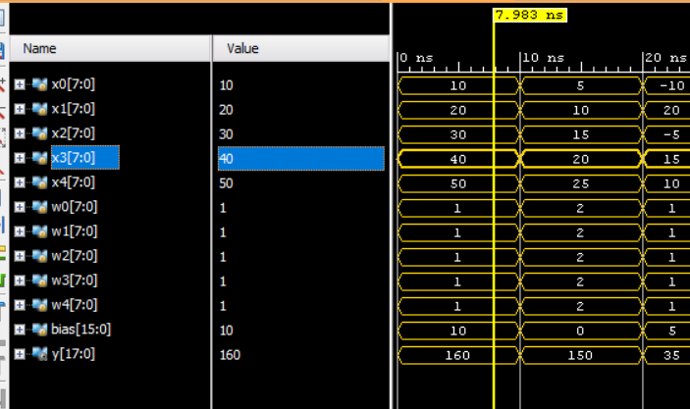
Figure 1: sample fully connected network output

Conclusion
The Fully Connected (FC) Neural Network layer with five input neurons was successfully designed, implemented, and simulated using RTL Verilog in Xilinx Vivado. The circuit executed 5 parallel signed 8-bit multiplications, accumulated product terms into an 18-bit register, and added the 16-bit bias value. Simulation waveforms across all 3 test cases (Positive values, Scaled weights, and Mixed signed negative inputs) matched theoretical MAC calculations with 0% error, confirming 100% functional accuracy of the hardware neuron for AI acceleration.

